
Assessment

Student Full Name | Klycya Silva
Student Number | 2026558
Module Title | Machine Learning
Assessment Title | PROJECT REPORT-Maternal Health Risk Classification
Lecturer/Supervisor
Assessment Due Date
Date of Submission

Use of AI Tools

I acknowledge the use of IA such as chat GPT, Claude and Gemini for the purpose of understanding better the view of the project, and how my title is interesting for the future publication. The IA have been used to complete the logic think about the proposal and help how to find the better way to prove the idea.

Contents
Introduction 1
Dataset Description and Preparation 1
Classification Models and Evaluation 1
3.1 Decision Tree Baseline 1
3.2 Confusion Matrix 2
3.3 Random Forest and SVM Comparison 3
Hyperparameter Tuning with Grid 3
Dimensionality Reduction Using PCA 4
Conclusion 6
References 6
Appendix 8

Introduction
Maternal health is an important public health topic because health risks during pregnancy need to be identified as early as possible. This project uses machine learning to classify maternal health records into three risk categories: low risk, mid risk and high risk. The aim is to investigate whether measurements such as age, blood pressure, blood sugar, body temperature and heart rate can help predict the risk category recorded in the dataset.
The task is a supervised classification problem. The input variables are known for each record and the target variable, RiskLevel, contains one of three labels. Classification is suitable because the required output is a category rather than a continuous numerical value. The project compares a Random Forest model and a Support Vector Machine (SVM), evaluates their performance using cross-validation and test data, tunes their parameters with GridSearchCV, and explores dimensionality reduction using Principal Component Analysis (PCA).
The models are intended for educational analysis only. They are not a medical diagnostic tool and must not be used to make decisions about an individual pregnancy. A real clinical application would require appropriate clinical validation, expert oversight, representative data and careful assessment of potential harm.

Dataset Description and Preparation
The dataset used is Maternal Health Risk Data Set.csv. It contains 1,014 records and seven columns. Six columns are predictor variables: Age, SystolicBP, DiastolicBP, BS, BodyTemp and HeartRate. The target column is RiskLevel. The dataset contains 406 low-risk records, 336 mid-risk records and 272 high-risk records. This means that low risk is the largest category, and high risk is the smallest, although all three categories are represented.
The initial inspection used the DataFrame shape, info() and isnull().sum() functions. The output showed 1,014 non-null values in every column, so no missing-value replacement was required. The six predictors are numerical, while RiskLevel is categorical. The predictor columns were selected as X and RiskLevel was selected as y. The data therefore had a clear separation between the information used to make predictions and the class the models were asked to predict.
For the first Decision Tree experiment, the data was divided into 70% training data and 30% test data using random_state=1. The later model comparison used stratified train-test splits with random_state=42 and test proportions of 5%, 15% and 25%. Stratification helps retain a similar distribution of risk categories in the training and test sets.

Classification Models and Evaluation

3.1 Decision Tree Baseline
A Decision Tree was first used as a baseline model. The classifier used the Gini criterion and a maximum depth of four. With a 70/30 split, the model achieved 66.23% test accuracy. The classification report showed different results across the three classes. High risk had precision of 0.84 and recall of 0.79. Low risk had precision of 0.58 and recall of 0.95. Mid risk had precision of 0.69 but recall of only 0.22.
The low recall for the mid-risk category means that the baseline model failed to identify many actual mid-risk records. This is important because accuracy alone does not show how well a model performs for each category. The confusion matrix and classification report provide additional information about these differences.
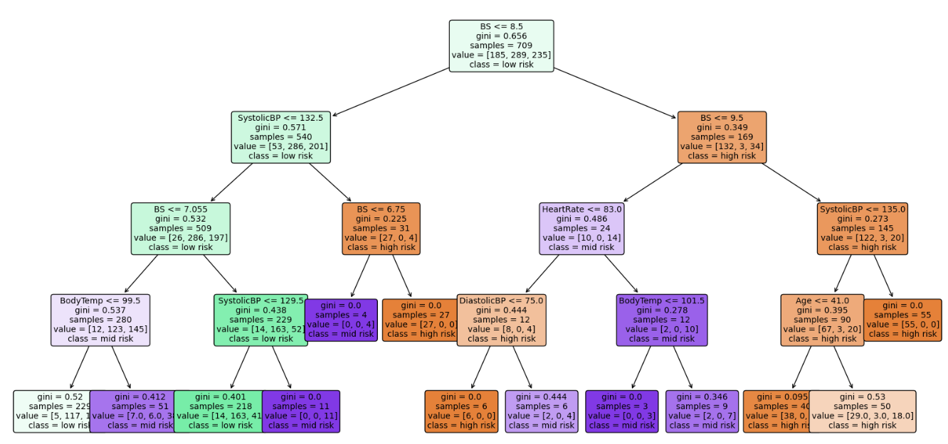
Graph 1 – Decision Tree

3.2 Confusion Matrix
The confusion matrix for the Decision Tree model shows the number of correct and incorrect predictions for each risk category. The class order is high risk, low risk and mid risk. Rows represent the actual class, and columns represent the predicted class.
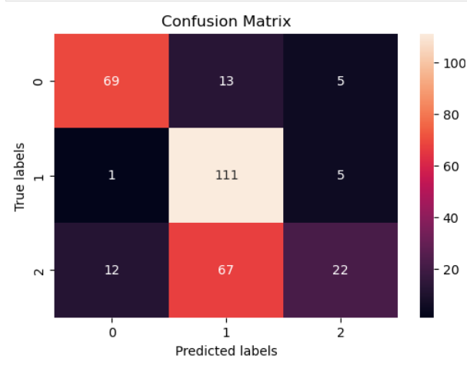
Graph 2 -Confusion Matrix
The diagonal values (69, 111 and 22) are the correctly classified records. The model correctly identified 69 of 87 high-risk records and 111 of 117 low-risk records, but only 22 of 101 mid-risk records,67 actual mid-risk records were predicted as low risk. This explains the low recall for the mid-risk class (0.22) in the classification report and shows why overall accuracy of 66% does not tell the whole story.

3.3 Random Forest and SVM Comparison
Random Forest achieved higher cross-validation and test accuracy than SVM in all three experiments. Its test accuracy increased from 78.43% with a 5% test set to 87.40% with a 25% test set. SVM test accuracy ranged from 68.63% to 71.65%. The results suggest that Random Forest was the stronger model for this dataset and these settings. The results also show why a model should be assessed using more than one split and why cross-validation is useful: it gives an estimate of performance across several training and validation folds rather than relying on a single split.
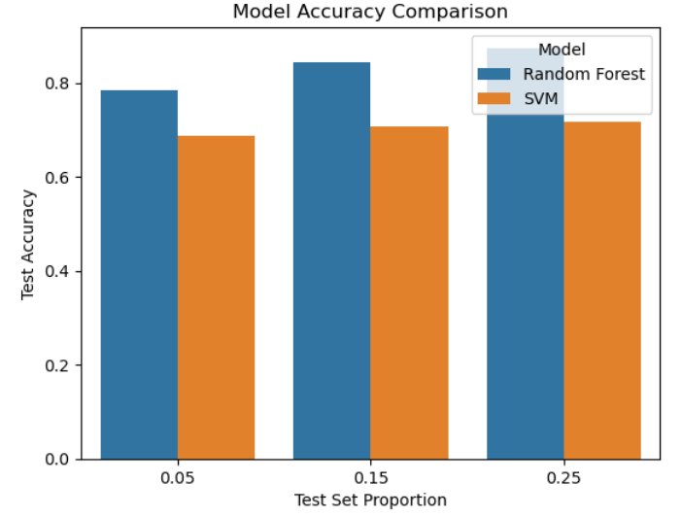
Graph 3 – Model Accuracy Comparison between Random Forest and SVM
The percentages in the table refer to the test-set proportion used in the notebook. Therefore, the corresponding training proportions were 95%, 85% and 75%. If the assignment specifically asks for training proportions of 5%, 15% and 25%. This interpretation should be discussed with the lecturer, and the experiment should be corrected or repeated if necessary.

Hyperparameter Tuning with Grid
Grid was used to test combinations of model settings with five-fold cross-validation. For Random Forest, the search tested 50, 100 and 200 trees; maximum depth values of None, 5 and 10; and minimum split values of 2 and 5. The best combination reported by the notebook was 50 trees, no maximum depth limit and min_samples_split=2. Its best cross-validation accuracy was 82.63%, and its test accuracy was 87.80%.
For SVM, the search tested C values of 0.1, 1 and 10, linear and radial basis function (RBF) kernels, and gamma values of scale and auto. The best combination was C=10, gamma=scale and an RBF kernel. The best cross-validation accuracy was 70.00%, while test accuracy was 70.47%. The tuned results continue to show higher accuracy for Random Forest than for SVM.
Model | Best parameters | Best CV accuracy | Test accuracy
Random Forest | n_estimators=50; max_depth=None; min_samples_split=2 | 82.63% | 87.80%
SVM | C=10; kernel=RBF; gamma=scale | 70.00% | 70.47%
Table 1 – Grid Accuracy
The tuning results above were produced using the 25% test split created before Grid. It selects the parameter combination with the highest average validation score, the separate test set is then used to estimate performance on unseen records. This separation is important because the test set should not be used to choose the parameters.

Dimensionality Reduction Using PCA
Principal Component Analysis (PCA) is a dimensionality reduction method. It combines the original variables into new components that capture variation in the data. It can be useful for simplifying data, reducing the number of input dimensions and making patterns easier to visualize (Jolliffe and Cadima, 2016).
Before PCA, the six numerical predictor variables were standardized using Standard Scaler. PCA was then used to retain the first two principal components. The data shape changed from 1,014 records and six features to 1,014 records and two components. The two components together explained 62.47% of the variance in the scaled predictors. This means that the two-dimensional representation retained some, but not all, of the variation in the original six variables.
A scatter plot of the first and second principal components was colored by Risk Level. This visualization allows the three classes to be compared in two dimensions.

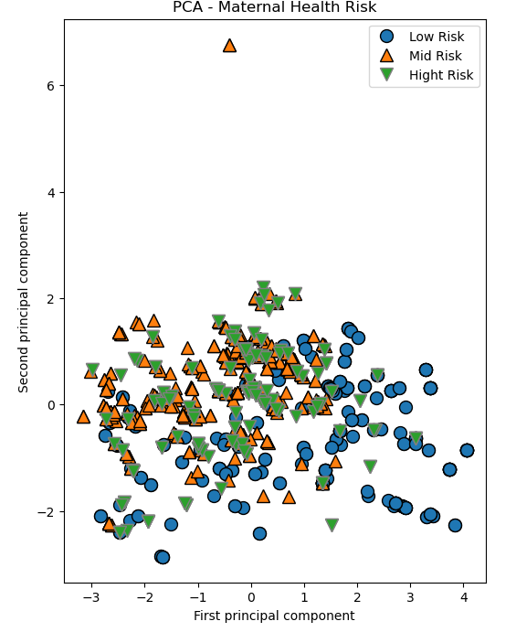
Figure 1 – PCA Maternal Risk Level
The heatmap of the PCA components displays the loading values for each original feature. In the first component, the largest positive loadings were DiastolicBP (0.524), BS (0.523), SystolicBP (0.445) and BodyTemp (0.425). In the second component, Age had the largest absolute loading (-0.767), followed by HeartRate (-0.453) and BodyTemp (-0.370). The signs indicate the direction of the relationship with a component; a negative value does not mean that a variable is unimportant.
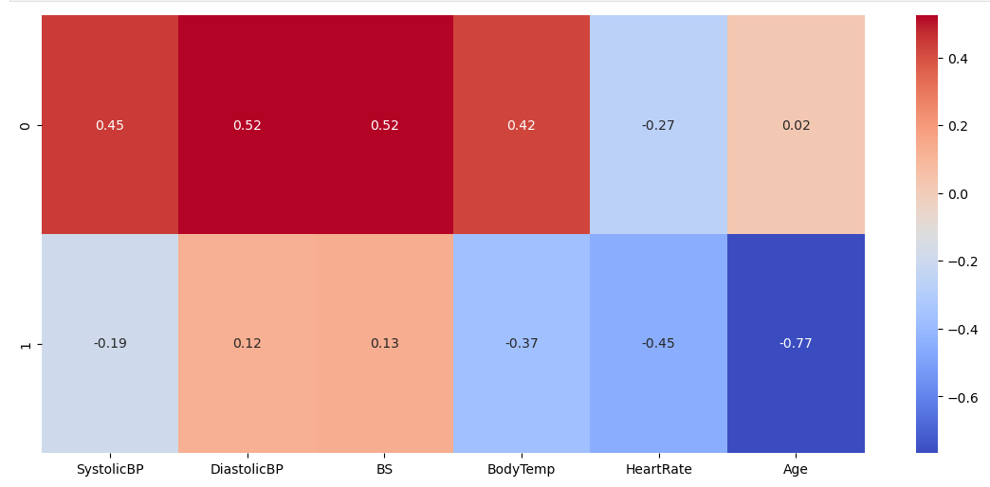
Heatmap 1 – PCA components
PCA is useful here for visualizations and understanding how the six measurements can be represented by fewer dimensions. However, two components explain 62.47% rather than all the variance, so some information is lost. Also, this notebook does not report a comparison of classification accuracy before and after PCA. Therefore, it is not possible to conclude from the current results that PCA improves model performance. The dataset already has only six predictor variables, so dimensionality reduction may be more useful for visualizations than for improving prediction.

Conclusion
This project applied supervised machine learning to classify maternal health records into low-risk, mid-risk and high-risk categories. Across the experiments, Random Forest produced the strongest accuracy results. It also performed better than the initial Decision Tree baseline the tuned Random Forest reached 87.80% test accuracy, compared with 70.47% for tuned SVM. Nevertheless, the baseline classification report showed that the mid-risk category was difficult to identify. Further evaluation should therefore include per-class precision, recall and F1-score for the tuned models, not only overall accuracy. This is particularly important in a health-related classification task, where errors across risk categories may have different consequences. The notebook contains a confusion matrix for the baseline Decision Tree, but it does not include separate confusion matrices for the tuned Random Forest and SVM models.
PCA reduced the six predictors to two components that explained 62.47% of the variance. The scatter plot and heatmap supported exploration of the data, but the notebook did not establish that PCA improved classification accuracy. Overall, Random Forest was the best-performing model in the experiments. More detailed class-based evaluation, leakage-free PCA validation and confirmation of the dataset's provenance would strengthen the project.

References
David McQuaid (2026) Science in Data Analytics for Business, Data Preparation - Lecture Materials. CCT College Dublin.
Muhammad Lqbal (2026) Science in Data Analytics for Business, Machine Learning - Lecture Materials. CCT College Dublin.

Jolliffe, I.T. and Cadima, J. (2016) ‘Principal component analysis: a review and recent developments’, Philosophical Transactions of the Royal Society A,
Cortes, C. and Vapnik, V. (1995) ‘Support-vector networks’, Machine Learning
Breiman, L. (2001) ‘Random Forests’, Machine Learning,

Appendix

OpenAI (2026) ChatGPT. Artificial intelligence model. (Accessed 06 November 2026). Check the grammar, clarity and academic English of my project text while preserving my original meaning and using clear, simple language.

